FINAL YEAR PROJECT PROPOSAL -- DVE(IT)
Project Title: AI-Powered Food Calorie Estimator Telegram Bot Using Computer Vision and Nutrition API (Short Name: CalorieSnap Bot)
Student Details:
Name: | Student ID: | email
MOK Ho Long | 230195053 | 230195053@stu.vtc.edu.hk
TSUI Shing Chin | 230213524 | 230213524@stu.vtc.edu.hk
WONG Sze Lap | 230342045 | 230342045@stu.vtc.edu.hk
WONG Tsz Chung | 230343030 | 230343030@stu.vtc.edu.hk
Supervisor: Ken LAU

1. Introduction of the Project
This project develops an AI-powered food calorie estimator bot based on the Telegram platform, aiming to provide users with convenient and real-time dietary and nutritional analysis services. The bot integrates computer vision and nutritional data API technologies. Users only need to upload food photos via Telegram, and the system automatically completes the following processes: (1) food detection and classification using a pre-trained deep learning model; (2) estimating food portion size and volume; (3) querying corresponding nutritional data through third-party nutritional APIs such as Nutritionix, Edamam, or FatSecret; and (4) calculating and reporting detailed information such as total calories, protein, fat, carbohydrates, and micronutrients.
The bot also supports multi-food mixed plate detection, Chinese and English dish recognition, and daily calorie recording and statistics functions to assist users in dietary management. The project is developed using Python, with the core framework including PyTorch/TensorFlow, the python-telegram-bot library, and the FastAPI backend, deployed on a cloud server to provide 24/7 service. This system combines practicality with technological innovation, providing a brand-new solution for mobile health management applications.

2. Objectives of the Project
This bot uses camera functions to take pictures of eating, analyzing the nutrients and calories in the picture through AI tools
Specific Objectives
- Creating weight loss apps that satisfy customers
- Take photos in real time and analyze what nutrients and calories are in the food in the image
- Use open ai gpt 4 vision to identify the food in the picture
- Use APIs to connect databases of food and nutrition
- Using tg botfather as a platform enables users to use our bot through everyday chat software

3. Target Users
- Fitness people
- Losing weight people
- Office workers want to control their health
- long-term illness
- student who want to learn more about healthy eating habits

4. Project Goal
- Telegram bot development using Python
- Image processing
- Integration with AI API
- Bot responds to photos with calorie estimate in <15 seconds
- Accuracy ≥70% compared to manual lookup (tested on 30 common meals)
- Clean, documented code on GitHub
- Working live bot link
future enhancement
- Custom-trained machine learning model
- User accounts and long-term meal history database
- Mobile app (native iOS/Android)
- Multi-language support beyond English
5. Problem Statement

Most people find traditional calorie tracking apps time-consuming because they require manually searching for food and entering portions. Examples include MyFitnessPal and MyNetDiary. Many users give up after only a few days.

Photo tracking is faster and more natural, but existing solutions are either paid, inaccurate, or require downloading a separate app. Currently, there is no free, accurate, and readily available local food tracking solution based on Telegram.

6. Storyboard & Design (User Flow)
1. User opens Telegram → searches @CalorieSnapBot → /start
2. Bot replies: "Hi! Send me a photo of your food and I'll tell you the calories!
3. User takes a photo → sends to bot
4. Bot replies "Analyzing your meal" (with typing indicator)
Bot returns formatted result within 5-10 seconds:

Example:
🍽️Recognized: Nasi
Lemak with fried chicken, cucumber, egg & sambal
💪Protein: 38g 🥔Carbs: 92g 🧈Fat: 45g
🔥Calories: 850 kcal
"Tip: Try reducing the rice portion to lower calories!"
5. User can immediately send another photo.
6. The AI ​​will save low records and generate a report every night at midnight, showing how many calories you consumed in total.

7. Gantt Chart

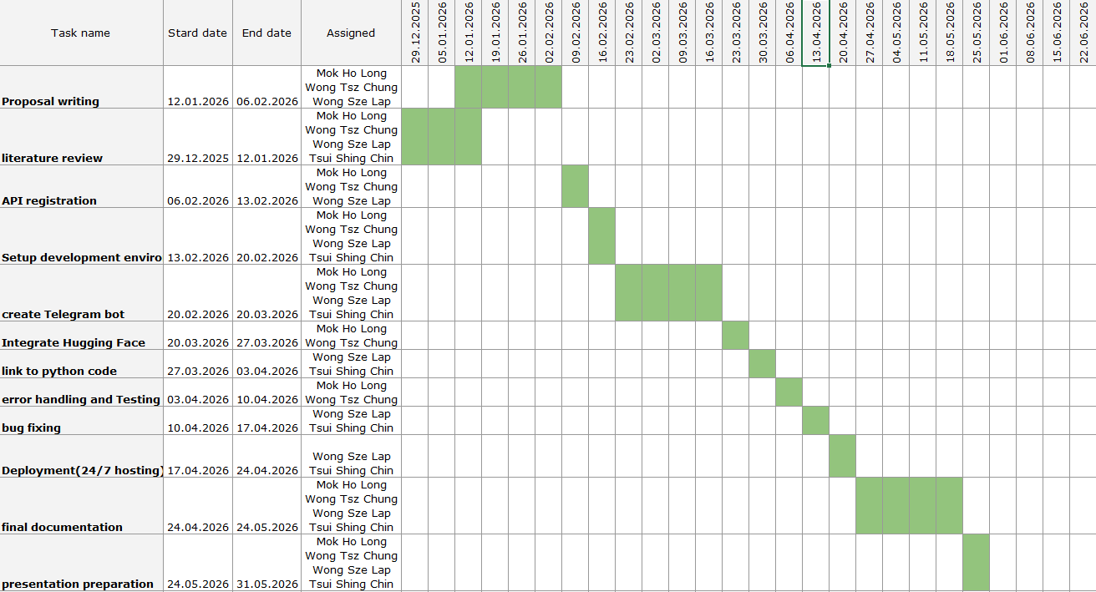

8. Project Requirements
Hardware
- Laptop/PC with python environment
- Smartphone with telegram for testing
Software & Services (mostly free tier)
- Python 3.13
- Libraries: telebot, base 64, os, huggingface-hub, dotenv
- Telegram Bot API (free)
- Hugging face-hub account, API
- GitHub for version control

9. References
- Telegram Bot API Documentation – https://core.telegram.org/bots/api
- Hugging hub – https://huggingface.co/docs/hub/index
- Qwen/Qwen2.5-VL-7B-Instruct – https://huggingface.co/Qwen/Qwen2.5-VL-7B-Instruct
- Github – https://github.com/
- Render.com – https://render.com

